SYSC5104A Methodology Discrete Event Modeling and Simulation

Assignment2: Cell-DEVS Models for the Spread of COVID-19 with Asymptomatic Infection

Mengyao Wu 101006768

Xinrui Zhang 101027055

Carleton University

November 12, 2020

Contents

Part I. Summary of Cell-DEVS Models for the Spread of COVID-19 1

Part II. Formal specifications and Simulation Analysis 2

Cell-DEVS Models for the Spread of COVID-19 with Asymptomatic Infection 2

Scenario 1. The effect of testing accuracy in asymptomatic COVID-19 to the spread of pandemic with sufficient testing resources 5

Scenario 2. The effect of testing accuracy in asymptomatic COVID-19 to the spread of pandemic with limited testing resources 7

## Part I. Summary of Cell-DEVS Models for the Spread of COVID-19

This paper applied Cell-DEVS formalism to model and simulate the spread of COVID-19. To be more specific, two models are formalized and simulated: Susceptible-Infected-Recovered (SIR) model and Susceptible-Infected-Recovered-Susceptible (SIRS) model. It starts with analyzing shortcomings with other simulation methodology and modelling techniques. It introduces Cellular Automata (CA) with its advantage and limitations. Cell-DEVS is used to overcome the limitations of CA. It also proves that any CA can be better defined with Cell-DEVS which provides equivalent modelling and better timing mechanism.

This paragraph explains why Cell-DEVS should be used to overcome limitations imposed by other simulation methodology. Formal mathematical methods such as ordinary differential equations are difficult to be applied in practice. CA overcomes their limitations with ease of defining contact processes, individual behaviors and spatial dimensions. However, CA is discrete time in its nature. With CA alone, each cell needs to be checked at a given time step. This is time consuming and it cannot not process events that should happen between each time step. The Cell-DEVS formalism solves the issue by combining CA and Discrete Event System Specifications (DEVS) to describe n-dimensional cell spaces as discrete-event models. Each cell is an atomic model in DEVS formalism. The whole cell space is a coupled model which connects each cell with its neighboring cells. Within each cell, it follows CA formalism while the coupling of whole cell space follows DEVS formalism. With this hierarchy, each cell is active only when it receives external events, or an internal event triggered. As a result, it becomes event-driven with continuous time base and only perform cell computation when it is necessary.

CD++ is a simulator that allows defining models based on the Cell-DEVS and DEVS formal specifications. The Cell-DEVS Web-viewer allows us to visualize simulation results, display cells information and activity.

An SIR model is defined with CD++ next. Each cell has N individuals. S, I, R represents the ratio of individuals who are susceptible, infected and recovered respectively in a specific cell. When the cell is active, it updates S, I, R, at every time step, with given equations and additional variables including mobility factor m, connectivity factor, infection rate. SIRS follow similar definition process with additional consideration of individual becomes S after R. SIRS has finer grain parametrizations to model a complex epidemic evolving pattern.

Two case studies are presented to validate the equivalence of Cell-DEVS SIR model and SIRS model, whose parameters are configured using data from the spread of SARS-CoV-2 in South Korea.

## Part II. Formal specifications and Simulation Analysis

### Cell-DEVS Models for the Spread of COVID-19 with Asymptomatic Infection

Rectangular screening zone is set up so that it aims to prohibit the infected individual from moving to other neighbour cells. The screening zones will isolate the symptomatic infection right away since it shows symptom. For the rest of the population, there should be asymptomatic infection. Rapid testing will be applied on the rest of the population so that it tries the best to detect asymptomatic infection. Both symptomatic infection and detected asymptomatic infection population are not allowed to move to other cells. However, it is obvious that the rapid testing is not 100% accurate which means small portion of asymptomatic infected people will be moving to other cells to cause the spread. This Cell-DEVS simulation aims to answer the question: Given certain rapid testing accuracy, how the spatial arrangement of testing places affects the spread of virus? Or, given certain limited resources of testing places arrangement, how much accuracy is needed from the rapid testing method?

Modifications are made on Moore effect model only. Cells are divided into 2 types: normal cell and screening cell. The infection type is also divided into 2 types: asymptomatic Infection and symptomatic Infection. The Moore effect is modified such that it takes weighted infection rate from both asymptomatic and symptomatic infection rate assuming asymptomatic infection has smaller infection rate. The infected population are then divided into asymptomatic and asymptomatic infection with a fixed ratio assuming asymptomatic has smaller proportion. Based on above modification, normal cell (cell type is 0 in the specification) operates in the same way as described in the paper summarized above. The screening cell (cell type 1) will output zero infected population with symptoms shown. At the same time, it only outputs certain percentage of asymptomatic infection to its neighbour cell. This is applied to simulate the testing accuracy for asymptomatic infection. Different testing accuracy and screening zone sizes are experimented below.

***Important parameters added:***

virulence_asym = 0.1 is the infection rate for asymptomatic infection. Asymptomatic infection has lower infection rate compared with symptomatic infection.

Asym_ratio = 0.2 means 20% of the newly infected population are asymptomatic infection

i_infec_show is symptomatic infection (symptoms shown)

i_infec_a is asymptomatic infection

cell_type distinguishes normal cell and screening cell

The formal specification for Cell-DEVS models for the spread of COVID-19 with asymptomatic infection is defined as:

TCD = < X, Y, I, S, θ, N, d, δint, δext, t, λ, D >

X = {φ}

Y = {φ}

I = <η, µ, Px, Pv>

η = 9, the neighbourhood size

P = {initial, infec, rec, pop, sus, infec_a, infec_show}

S = {population, virulence_infec, virulence_asym, connection, movement, i_sus, i_infec, i_rec, i_infec_a, i_infec_show, cell_type=1}

N = {(-1,-1), (-1,0), (-1,1), (0,-1), (0,0), (0,1), (1,-1), (1,0), (1,1) } for η = 9;

delay = transport delay

d = 1

θ = {(s, phase, δqueue, δ)}

δint : {φ}

δext : {φ}

τ : For every cell {

If it is not initialized (initial value is -1)

Initial = 0

pop = $population

infec = i_infec

sus = i_sus

rec = i_rec

infec_a = i_infec_a

infec_show = i_infec_show

If the cell is initialized and cell type is normal

pop = population

infec = i_infec

sus = i_sus

rec = i_rec

infec_a = i_infec_a

infec_show = i_infec_show

i_rec = (recovered people in the cell+ recovery rate*infected people in the cell)*100/100

i_infec = ((1 – recovery rate)*infected people in the cell + #macro(i_effect_moore))*100/100

i_infec_show = i_infec * (1 – asymptotic ratio)

i_infec_a = i_infec * (asymptotic ratio)

i_sus = 1 – i_rec -i_infec

if the cell is initialized (cell type is screening cell)

pop = population

infec = i_infec

sus = i_sus

rec = i_rec

infec_a = i_infec_a *(1- test accuracy)

infec_show = 0

i_rec = (recovered people in the cell+ recovery rate*infected people in the cell)*100/100

i_infec = ((1 – recovery rate)*infected people in the cell + #macro(i_effect_moore))*100/100

i_infec_show = i_infec * (1 – asymptotic ratio)

i_infec_a = i_infec * (asymptotic ratio)

i_sus = 1 – i_rec -i_infec

}

λ : {φ}

D : until simulation ends

### Scenario 1. The effect of testing accuracy in asymptomatic COVID-19 to the spread of pandemic with sufficient testing resources

We first study that how different testing accuracy in asymptomatic COVID-19 would affect the spread of the pandemic. As demonstrated in figure 1 (left), we keep the current setting that the screening zone for quarantine and testing shaped in grid shown in green, surrounding large normal zones (size 10x10)which are made up of normal cells where people can move without limitation in light red. The initial outbreak of the epidemics is in the northwest shown as two black dots in the figure 1 (right). Once entering the screening zone, people will be tested for asymptomatic COVID-19. People with COVID symptoms and people without symptoms but tested positive are not allowed to leave the screening zone to cut down the spread of the pandemic.

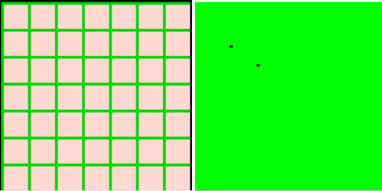

Figure current settings(left) and initial outbreak of COVID (right)

The figure 2 shows the spread of COVID-19 under different testing accuracy in asymptomatic COVID-19. The green color indicates that the cell is a safe area where infection rate is almost zero. The red color means the people in that area got infected and the heavier the red, the higher the infection rate.

When the testing accuracy in asymptomatic COVID-19 is 85% (figure 2, right), the pandemic will cross the screening zone border even though we stop the people who tested positive. The rest 15% asymptomatic infected people move to other areas and causes more areas seriously infected. As the testing accuracy in asymptomatic COVID-19 increases, less areas are heavily infected but still cannot stop the spread by quarantining all tested asymptomatic people. Eventually, if we can increase the testing accuracy to 89%, then the spread of the pandemic will be controlled by the screening zone illustrated in figure 3.

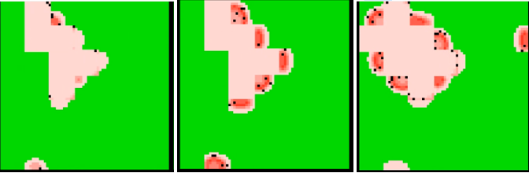

Figure : The infection rate of COVID-19 when testing accuracy in asymptomatic is 88% (left), 87%(middle), and 85% (right) in a 10x10-sized normal area after 3 days/unit time

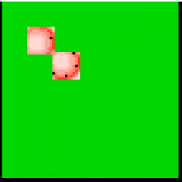

Figure The infection rate of COVID-19 when testing accuracy in asymptomatic is 89% in a 10x10-sized after 3 days/unit time

Under the condition of 88% testing accuracy in asymptomatic COVID-19, we can control the pandemic by reducing the normal area size or increase the screening grid density. As shown in figure 4, when normal area size is 15x15, it cannot stop the spread of the epidemic. As the size decreasing to 10x10, it slow down the spreading process but it cannot terminate the spread. When the size is reduced to 8x8, the spread of pandemic is successfully controlled and is not infecting any other safe area.

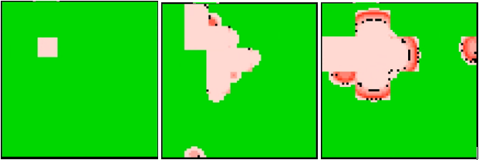

Figure 4 The infection rate of COVID-19 when testing accuracy in asymptomatic is 88% with a normal area size 8x8(left), size 10x10(middle) and size 15x15 (right)

In conclusion, when the density of the screening area is fixed, the spread of the COVID-19 can be terminated by high-level of testing accuracy in asymptomatic COVID-19, in our cases, 89%. Oppositely, if the existing testing technology can only achieve certain level of accuracy, people can still stop the spread of the pandemic by increasing the density of screening area.

### Scenario 2. The effect of testing accuracy in asymptomatic COVID-19 to the spread of pandemic with limited testing resources

As mentioned in the first scenario, the simulation of different testing accuracy in asymptomatic COVID-19 with a 10x10 sized normal area are performed. Based on the previous results, a decent testing accuracy in asymptomatic COVID-19, 88%, is used in the following simulation. Under this testing accuracy, we increase the size of normal area to 18x18 shown in figure 5 (right). The spread of the epidemic is not stopped successfully as illustrated in figure 6 (right). Next, we increase the proportion of screening area slightly, and change the normal area to 15x15 shown in figure 5 (left). However, the epidemic still spreads all around as illustrated in figure 6 (left).

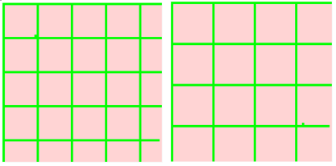

Figure Environmental settings with the size of normal area 15x15(left) and 18x18(right)

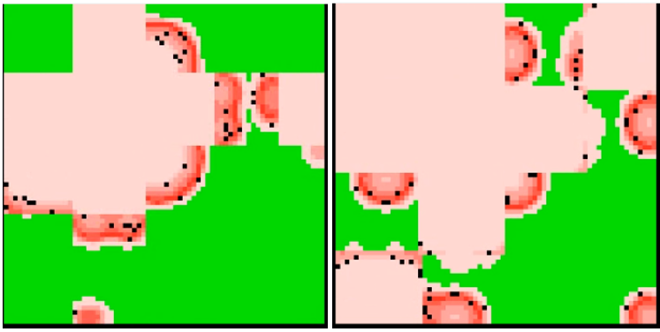

Figure The infection rate of COVID-19 when testing accuracy in asymptomatic is 88% with a normal area size 15x15(left), and size 18x18 (right) after 4 days/unit time

If the testing accuracy in asymptomatic COVID-19 can increase by 1% to 89%, the result is much delightful. Under this testing condition, the spread of the pandemic is controlled with a normal area size 18x18. After more simulation runs, it has been proved that 89% testing accuracy even can isolate the spread under 25x25 normal area size, whose area is more than two times larger than the area setting in scenario 1. It is also worth mentioning that the spread of the pandemic is related to the initial outbreak. This can be one of the future works to study this area.

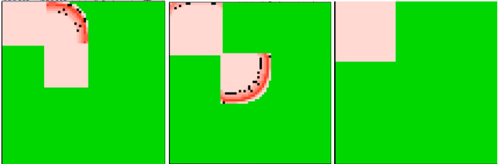

Figure The infection rate of COVID-19 when testing accuracy in asymptomatic is 89% with a normal area size 18x18(left), 22x22(middle), and size 25x25 (right) after 3 days/unit time